Problem:
Currently weapons issuing is a manual process and this would give rise to mistakes either during issuing by the store man or by the serviceman when writing personal details into the arms book.
It is noted that the manual process also increased the amount of time it takes for the duty officer to actually check the status of the weapons.

Proposed Solution:
By automating the process of issuing and returning of arms, we would be able to reduce the amount of books that need to be managed and the amount of mistakes that is introduced by handwritten details.
It would also reduce the amount of time needed for the duty officer to check the status of the weapons as he would have access to a summary of what is loan out, what is in store, etc.

Possible solutions:
There are 2 possible solutions, first is to use Barcode, the other is to use RFID.
.
Below is the comparison of the 2 technology
Barcode | RFID
Limited Data | More Data storage
Can not change data | Can change data
Lower deployment cost | Higher deployment cost
More simple to deploy (barcode scanner can act like a key board) | More complex as there maybe a need to read & write data into the tag
Barcode 1 cents or less | Tag 50 cents or more
Scanner $400 | Scanner $1000
Need to have line of sight | Can scan from distance
Scan slower | Scan faster (40 tags/sec)
No collision of readers or tags | Possible collision of readers or tags

Barcode is the cheaper of the two solutions, but it requires line of sight and so cost more in terms of manpower / time spent to operate as there is a need to rotate the weapon to find the barcode before it can be scanned. Barcode is limited by the amount of space for the label, and once generated / printed, it can not be changed.

Whereas for RFID, the initial cost of deploying the solution would cost more than Barcode. But the cost of operating it is less than that of barcode as all items can be scanned together and there is no need to have line of sight. RFID is limited by the amount of space on the chip within the tag and also the type of data that needs to be stored on the chip as not all forms of data is necessary. It is also possible to have a form of smart shelves (A*Star & NLB project) where weapons place into the shelves are automatically checked in. It would also facilitate the DO to do his checks as the system would be able to automatically account for the number of weapons in the shelves.

Below are the process flows for the current & proposed system.

As-Is (Issue)
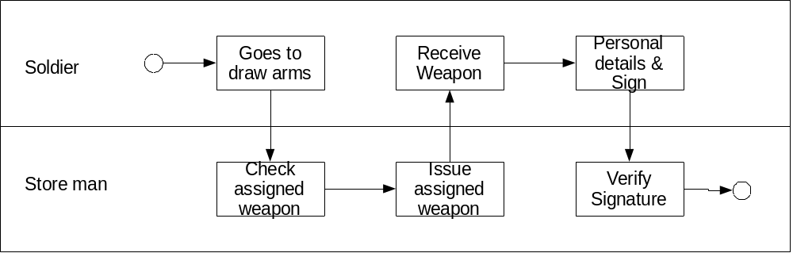

To-Be (Issue)
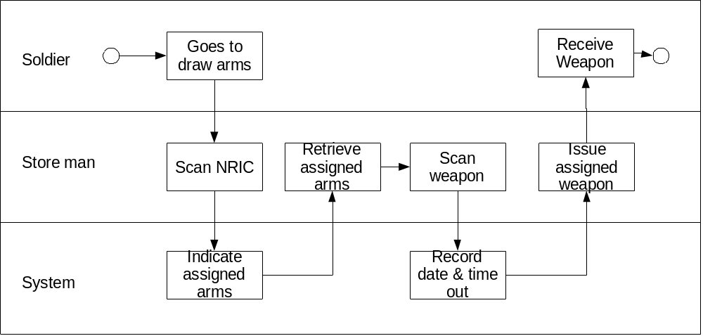

As-Is (Return)
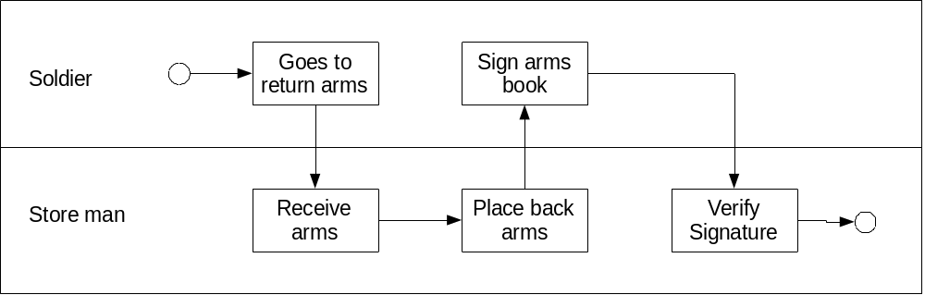

To-Be (Return)
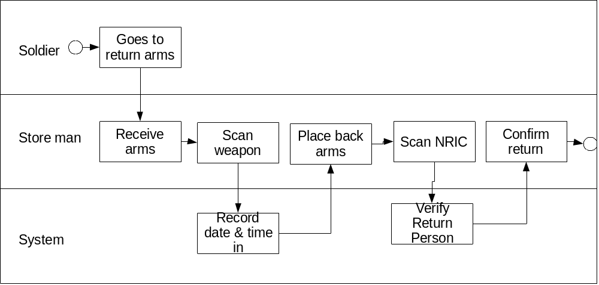

DB Structure

User
NRIC | NAME | RANK | UNIT | COY | APPT
S8470182C | Foo Ce-Wei | 3SG | BTMC 1 | HQ | TRG SPEC

CE
S/N | NAME | TYPE | LAST INSPECTION DATE
R001 | PRC 77 | Radio | 010109
SAR001 | SAR 21 | Small Arms | 010109

LOAN RECORD
NO | NRIC | S/N | DATE TIME OUT | DATE TIME IN
01 | S8470182C | SAR001 | 110509,1200 | 110509,1700
02 | S8470182C | R001 | 110509,1200 | 110509,1700

RANK
NO | RANK
01 | LG
02 | MG
03 | BG
04 | COL
05 | LTC

UNIT
NO | UNIT
01 | 1 SIR
02 | 2 SIR

